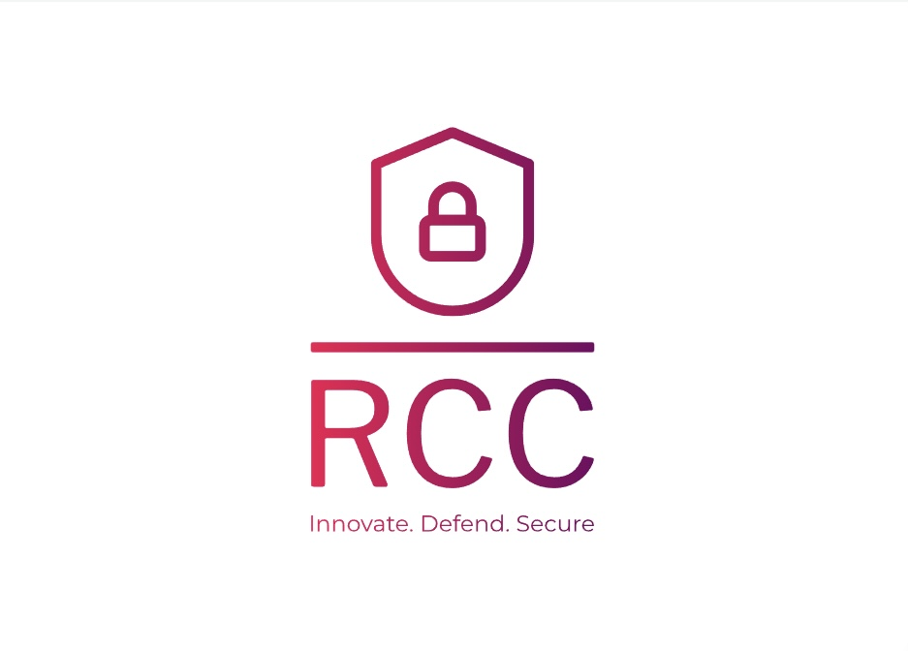

**Rensselaer CyberSecurity Collaboratory (RCC)**

Meena Mall | Ben Manicke | Peter Krumpholz | Raphael Chung

Introduction:

In partnership with Brian Callahan, the Rensselaer Cybersecurity Collaboratory (RCC) is committed to advancing our mission and influence in cybersecurity during the current term. To achieve this, the project team has embarked on three transformative projects. The first project involves the creation of a compelling public-facing website, which will serve as a powerful magnet to attract potential donors and sponsors. Simultaneously, the team is hard at work developing a comprehensive Capture the Flag (CTF) management system. This system is envisioned as a central knowledge hub, designed to empower users with the ability to access, edit, and create CTF challenges. Additionally, the team is pioneering a cutting-edge front-end semi-prototype that offers a tantalizing preview of our upcoming management system. The collective goal is to complete these projects by the end of the term, propelling the RCC to new heights in cybersecurity innovation and community engagement. Together, Brian Callahan and our dedicated team are poised to shape the future of cybersecurity.

Client Organization:

The Rensselaer Cybersecurity Collaboratory (RCC) currently serves as the main cybersecurity research center at Rensselaer Polytechnic Institute. The RCC researches a wide range of cybersecurity related topics and competes in various “Capture the Flag” (CTF) challenges. The organization is currently looking to expand its outreach and collect donations to increase funding. The point of contact with the RCC is through the Director Brian Callahan and who can be contacted at [callab5@rpi.edu](mailto:callab5@rpi.edu).

Project Team:

**Meena Mall:**

Meena Mall performs the roles of both Project Manager and Project Designer. Her many duties include comprehending the client's requirements, managing the project team, keeping track of the progress, and ensuring quality. Meena handles the project's numerous components to ensure a smooth completion. As the project designer, she participates in the project's visual and creative components, as well as incorporating client feedback and assisting in a successful project conclusion.

**Benjamin Manicke:**

Ben Manicke takes on the roles of Lead Frontend Developer and Lead Writer. As the Lead Frontend Developer, Ben works on developing the user-facing elements to provide an engaging and interactive user experience. He will perform extensive accessibility testing to ensure that our site is usable by all users. Additionally, he contributes to the project's written content as the Lead Writer by providing informative and engaging material.

**Peter Krumpholz:**

Peter Krumpholz is the Lead Backend Developer, currently pursuing a Bachelor’s Degree in Information Technology and Web Science with a concentration in Management Info Systems. He has several years of experience with both back and frontend development across multiple projects. Peter is taking the lead on backend development due to prior project experience involving organizing databases and handling database queries.

**Raphael Chung:**

Raphael Chung works as a Fullstack Developer to ensure a comprehensive, integrated system. He will assist both the backend and frontend developers in creating their sections of the code. He additionally serves as an Assistant Writer, helping the Lead Writer create written materials such as reports.

Problem Statement:

The Rensselaer Cybersecurity Collaboratory (RCC) community currently lacks a centralized digital platform to effectively showcase its achievements, profiles, events, and alumni engagement, making it challenging to attract potential donors and sponsors. Additionally, there’s an absence of a streamlined system for members to access, upload, and search through “Capture the Flag'' (CTF) writeups, hindering knowledge sharing and collaborative learning. Furthermore, while there’s a backend for CTF challenges, it’s missing an intuitive frontend interface that can provide users with an interactive and immersive challenge-solving experience. This fragmented and under-optimized digital presence limits RCC’s outreach, engagement, and learning potential.

IS/IT Solution:

The current aim is to create a holistic digital ecosystem tailored for the RCC community. The solution is to amalgamate the showcasing prowess of a public-facing website with the functional utility of a knowledge management system. The website will showcase RCC’s milestones, achievements, and events, while also serving as a dynamic platform for faculty, student, and alumni profiles. This website will not only foster community engagement but also attract potential donors and sponsors. Complementing this is a knowledge management system designed for the easy archival, search, and retrieval of CTF writeups. It will act as a knowledge hub, streamlining the process of uploading diverse content types, from text and images to videos and binaries. An ambitious attempt will also be made to craft a frontend that interfaces seamlessly with an existing CTF backend. Drawing inspiration from the Ghida project, this component aspires to offer users an immersive experience, from delving into challenge binaries to the triumphant capture of flags. Together, these elements coalesce to form a solution that not only celebrates the RCC community’s achievements but also empowers its members with tools for continuous learning and challenge-solving.

Scope/Methodology:

The project’s primary focus is designing and developing a public website compliant with RPI guidelines, highlighting RCC’s success, faculty, student profiles, events, and alumni engagement, complete with a unique RCC logo. Parallelly, a secure knowledge management system will be established, allowing authenticated access to a database of CTF writeups, facilitating easy uploads and searches. As an aspirational component, the project will explore crafting a frontend to interface with a pre-existing CTF backend, presenting users with interactive modules for challenge-solving. However, the full delivery of this third component is recognized as a reach goal and may not be fully realized within the project’s timeframe. The primary focus is ensuring the completion of component 1 and 2 while completing these in sequential order. The first components website will be designed using Bootstrap and React while the logo will be developed using tools from Adobe Creative Cloud. Next, the knowledge management system will be implemented using MongoDB and Node.js. Finally, the third component will require the entire MERN stack to implement a well designed and cohesive final product.

IS/IT Requirements:

Based on the proposed IS/IT solution, several technologies will be required to achieve the finalized product. Considering the project team’s use of the MERN stack, the primary requirement for the public-facing website is that it must be served with Node on a live server so that it can be accessed by anyone on the web. The frontend of the site must be in-line with current RPI branding and theming as well as following all of RPI’s accessibility guidelines. Additionally, Express JS & React will be used to build all of the pages dynamically alongside Node. Besides developing the custom frontend, the project team is also required to create a backend that contains a knowledge management system for the existing Capture The Flag (CTF) write-ups using MongoDB, as well as all of the javascript and other necessary code to allow users to create, delete, edit, and search for any CTF write-ups they have permission to access. Finally, the project team must implement a secure login system for users who want to access more than just the public facing website. This login system will authenticate users via RPI’s CAS system, pending client and organization approval, and will require all user input data remain private and secure.

CBA/Risk Management:

There are several possible risks the project team could face and establishing a baseline number of these risks allowed for the project team to calculate a probability impact score of 73.33 (effects of this shown in CBA and Risk Analysis sheet). The main risks the team calculated for were Level of Complexity, Level of Customization, Configuration Detail, Data Specificity, Cybersecurity threats, Regulatory compliance, Lack of User Acceptance, Change in Requirements, Timeline, and Integration Faults. The project team has set up plans to be prepared to tackle each of these risks if they arise and will articulate to the client if any of these possible issues require a change in overall scope, complexity, or budget.

Project Management:

The project will be managed by PM Meena Mall and it is split up into several different portions of varying scope. After setting up a complete plan, establishing the requirements, and creating a CBA , all of which must be approved by the client, the team will begin development of the proposed IS/IT solution. Principally, the team will create wireframes and begin creating the frontend website ensuring all code is validated as it is developed and pushed to the group GitHub. Upon completion of the frontend it will be presented to the client for feedback and/or approval and the team will begin working on the backend portion of the project. Similarly to the frontend implementation, the backend will require wireframes to be developed and all code must be validated as it is created and pushed to the team Github. Upon completion of the initial development of the backend, it will be presented to the client for feedback and/or approval and the team will embark on the process of developing and testing a full prototype of the project. Once the team has completed and finalized the prototype, testing will begin and upon successful testing, the final project will be delivered to the client and deployed on the web. Once delivered, the project team will submit a final report and deliver a presentation to the client and Prof. Grill.

Post Turnover Plan:

Subsequent to the final submission of the completed IS/IT solution, and acceptance of the solution by the client, the project team will serve the custom website to the web via Node, React, and Express JS so that it can be accessed by the general public. Several days to weeks after the website is published, the project team will meet with the client to discuss any possible improvements / pain points that need to be remedied as well as discussing how to continue to innovate and update the website well into the future.